CLASS BROCHURE
A Database-Driven Student Directory & Portfolio Platform
for BCA Batch 2023 – 2027
A Project Report submitted for
Project Implementation, Database Design & Documentation
Submitted by
Ashmit Kiran Bhandary
Register No. 2343011
Bachelor of Computer Applications (BCA)
Department of Computer Science
CHRIST (Deemed to be University), Yeshwanthpur Campus, Bengaluru
September 2026

Table of Contents
1. Abstract 3
2. Objective 3
3. Description of the Front-End 4
4. Database Used — Detailed Report 5
5. Entity–Relationship (ER) Diagram 7
6. Use Cases 8
7. Database Connectivity 9
8. Results 10
9. Conclusion and Future Scope 13

1. Abstract
Batch-level student information at CHRIST (Deemed to be University) — photographs, resumes, technical and professional skills, project portfolios and contact details — has traditionally been scattered across individually collected PDFs, spreadsheets and messaging-app threads, making it hard for recruiters, faculty and the students themselves to locate a current, complete profile. This project designs and implements "Class Brochure," a database-driven web application that consolidates the BCA 2023–2027 batch (35 students) into a single searchable directory with individual, richly detailed profile pages.
The front end is a single-page application built with React 19 and Vite, styled with a custom glassmorphism design system and animated with Framer Motion. The application layers two data sources at render time: a static, build-time dataset (src/data/students.js) that seeds every profile with the information gathered at launch, and a dynamic NoSQL document database — Google Firebase Firestore — that stores only the fields a student has personally edited after launch, keyed by student ID. A lightweight, password-gated self-edit flow lets each student update their own tagline, biography, skills, certifications, projects, contact links and resume without any developer involvement or redeployment; changes are pushed to every visitor in real time through Firestore's onSnapshot listeners. Resume files are streamed directly from the browser to Cloudinary's unsigned upload API, keeping the document database itself lean (it stores only the resulting URL, not the file).
The resulting system was implemented, built for production, and verified end-to-end using an automated headless-browser test pass in addition to manual review, and is deployed as a live, publicly reachable site. This report documents the front-end architecture, the database design (including an entity-relationship view of the underlying Firestore data model), the application's use cases, how the application connects to and operates against the database, and the results observed when running the finished system.

2. Objective
The project set out to achieve the following objectives:
- Design and implement a centralized, database-backed student directory for the BCA 2023–2027 batch that consolidates profiles, skills, projects, and resumes in one place, replacing scattered spreadsheets and individually-shared PDFs.
- Build a responsive, fast front end that lets a visitor (recruiter, faculty member, or classmate) search and filter all 35 student profiles by name or technical skill, and drill into a full profile in one click.
- Design a lightweight NoSQL data model, backed by Firebase Firestore, that lets each student self-edit their own profile after launch without requiring a developer to touch the codebase or trigger a redeploy.
- Implement a database write path with a practical (password-gated) access-control model, and integrate a third-party file-storage service (Cloudinary) for self-service resume uploads, keeping the primary database schema lean.
- Verify database connectivity end-to-end — reads, real-time subscriptions, and writes — and confirm the behaviour degrades gracefully if the database configuration is ever missing.
- Deploy the finished application as a live, publicly reachable website and document its architecture, data design, and observed results.

3. Description of the Front-End
The client application is a single-page application (SPA) built with React 19 and bundled with Vite 8. Vite was chosen over a heavier framework (e.g. Next.js) because the application has no server-rendered routes and no backend of its own to host — every page is client-rendered and the finished build is a set of static files that can be served from any static host (the project is deployed on Vercel, with an alternate GitHub Pages workflow also configured).

3.1 Component Architecture
The UI is composed of focused, single-purpose React components rather than one monolithic page:
Component | Responsibility
Navbar | Sticky glassmorphism navigation bar; reads the batch label directly from the data layer so it never needs manual updates.
Hero / CinematicHero | Landing section introducing the programme and batch.
ProgramOverview | Summarises the BCA programme structure (duration, semesters, specialisation electives).
AboutCohort | Cohort-level statistics (student count, skills documented, projects, certifications).
Directory | Searchable, filterable grid of all 35 student cards; the core browsing surface.
StudentProfile | Full-page profile view: about, skills, education, projects, certifications, and contact.
EditProfileModal | Two-step self-edit flow: login, then a form that writes back to the database.
ResumeViewer | Renders an uploaded resume PDF inline using pdf.js, without leaving the page.
MailChooser | Generates "compose" deep links for Gmail, Outlook.com, Yahoo Mail, and the OS default client.
PlacementEnquiry / Footer | Batch-level contact surface for recruiters and department contacts.

3.2 State, Data Flow, and Navigation
Application state is managed with plain React hooks (useState, useEffect, useMemo, useRef) and a single React Context (OverridesContext) rather than an external state-management library — the app's state surface is small enough that Redux or similar would have added complexity without benefit. OverridesContext subscribes once, at the top of the component tree, to the Firestore collection that stores self-edits, and hands the live map down to whichever screen needs it (the directory grid and any open profile page), so an edit saved from one screen is reflected on the other without a page reload.
Rather than a client-side router, App.jsx keeps the homepage mounted at all times and toggles a full-page StudentProfile view over it, restoring the visitor's original scroll position (captured in a ref) when they navigate back — this keeps the directory's search text and active filter intact across a profile visit, which a full route change would otherwise reset.

3.3 Styling, Animation, and Libraries
Visual design uses hand-written, component-scoped CSS plus a custom GlassSurface component that builds a live glassmorphism effect using an SVG feDisplacementMap filter, so the navigation bar visibly refracts the content behind it rather than using a flat CSS blur. Framer Motion drives entrance and hover animations (card lists, modal transitions, the mobile menu), and lucide-react supplies the icon set.
Package | Version | Role
react / react-dom | ^19.2.8 | Core UI library
vite / @vitejs/plugin-react | ^8.2.0 / ^6.0.4 | Dev server and production bundler
firebase | ^12.17.1 | Firestore client SDK (database connectivity)
framer-motion | ^13.1.0 | Animation
lucide-react | ^1.31.0 | Icon set
oxlint | ^1.75.0 | Static linting

4. Database Used — Detailed Report

4.1 Choice of Database
The application uses Google Firebase Firestore, a managed, schemaless NoSQL document database, as its primary database. Firestore was chosen over a traditional relational database (e.g. MySQL/PostgreSQL) for three project-specific reasons. First, the data itself is naturally document-shaped rather than strictly tabular — a single student "record" contains nested arrays (technical skills, professional skills, certifications, a list of project objects), which map directly onto a JSON document without needing a normalised multi-table join. Second, Firestore ships client-side real-time listeners (onSnapshot) out of the box, which is exactly the behaviour the self-edit feature needed — any visitor's edit should appear for every other visitor immediately — without standing up and hosting a custom backend server or WebSocket layer. Third, because the front end is a static site with no server of its own, Firestore's browser SDK, which talks to the database directly and securely over HTTPS using project-scoped security rules, was the only option that did not require provisioning and paying for separate backend hosting.

4.2 Two-Tier Data Architecture
Rather than storing every student field in the database, the application deliberately splits student data across two tiers, merged only at render time:
- Static seed data — src/data/students.js, committed to the source repository. This is the "source of truth" baseline: 35 JavaScript objects, one per student, populated at project launch from resumes and photos each student submitted through a Google Form. It is bundled into the production build and requires no database round-trip to read.
- Dynamic overrides — the studentEdits collection in Firestore. This collection stores only the fields a student has personally changed since launch, as one document per student keyed by the same id used in the static file. It starts empty for every student and is populated only when that student uses the self-edit flow.
At render time, withOverrides(student, overridesMap) performs a shallow merge — any field present in a student's Firestore document overwrites the corresponding static field; every field the student has never edited simply falls back to the static baseline. This design means the live database only ever has to store a small, changing subset of the total data, and the deployed static site never needs to be rebuilt or redeployed for a profile edit to take effect.

4.3 Collection / Document Schema
Firestore is schemaless (any document may in principle carry any fields), but the application consistently writes and reads the following logical schema for every document in studentEdits:
Field | Type | Notes
(document ID) | string | Equal to the student's static id (e.g. "stu-010") — this is what links a Firestore document back to its static record.
tagline | string | Short one-line role/summary shown on the card and profile header.
bio | text | Free-text "About" paragraph.
priorEducation | string | Pre-university education line.
technicalSkills | array<string> | Rendered as the "Technical Skills" column.
professionalSkills | array<string> | Rendered as the "Professional Skills" column.
certifications | array<string> | One entry per certification.
projects | array<object> | Each item: { title, desc, link } — an embedded sub-document, not a separate collection.
email | string | Also used to verify identity at self-edit login.
linkedin / github | string (url) | Direct profile channel links.
resumeUrl | string (url) | Set only after a self-service resume upload; a Cloudinary-hosted URL, not the file itself.

4.4 Real-Time Synchronisation
A single subscription — subscribeOverrides(), wrapped by OverridesContext — is opened once when the app loads, via Firestore's onSnapshot(collection(db, 'studentEdits')). Firestore pushes the full current snapshot immediately, and pushes again automatically whenever any document in the collection changes, without the client polling or reloading. Every subsequent snapshot is reduced into a plain { studentId: fields } map and stored in React state, so a change becomes visible in the directory grid and any open profile within roughly a second of being saved by another visitor.

4.5 Write Path and Merge Semantics
A save from EditProfileModal calls saveOverride(studentId, data), which performs setDoc(doc(db, 'studentEdits', studentId), data, { merge: true }). The merge: true option is a deliberate design choice: without it, saving just an updated bio would overwrite the entire document and silently delete any previously-saved resumeUrl or other fields; with it, only the fields present in that particular save are written, and everything else already stored for that student is preserved untouched.

4.6 Access Control
Firestore Security Rules (firestore.rules) scope read/write permissions per collection. The current ruleset allows public read and public write on studentEdits, and denies everything else by default. Write access is not backed by Firebase Authentication; instead, EditProfileModal performs a client-side check — the visitor must enter the email already on file for that specific student plus a shared class password before the edit form unlocks. This is intentionally documented in the codebase as a "soft gate" against casual editing, not a cryptographic guarantee that only the actual student can write to their own document — a limitation worth stating plainly, since a real hardening step (wiring up Firebase Authentication with per-user rules matched to a verified email) is a natural next iteration rather than something silently glossed over.

4.7 Auxiliary Storage: Favorites and Resume Files
Two pieces of data are deliberately kept out of Firestore. "Favorites" — a personal shortlist a visitor builds while browsing — is stored in the browser's localStorage only, because it is specific to whoever is looking right now and should not appear starred for every other visitor; syncing it centrally would have been the wrong design. Resume PDFs are not stored as binary data in Firestore at all (Firestore documents are capped at 1 MiB and are not designed for large binary blobs); the static seed resumes ship as build-time files under public/resumes/, and a self-uploaded replacement is streamed directly from the browser to Cloudinary's unsigned upload endpoint. Only the resulting permanent URL is written into the resumeUrl field in Firestore — the database stores a pointer to the file, not the file.

5. Entity–Relationship (ER) Diagram
Because Firestore is a schemaless NoSQL document database rather than a relational database, it has no native tables, foreign keys, or join constraints. The diagram below is therefore a logical / conceptual entity-relationship view: it documents the same information a relational ER diagram would (entities, their attributes, and how they relate), mapped onto the collections, embedded arrays, and browser-local storage the application actually uses.
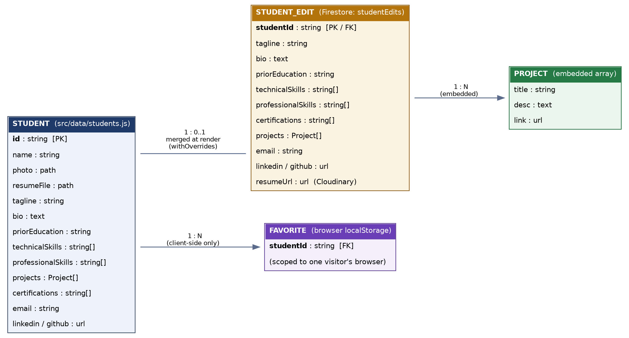
Figure 1. Conceptual ER diagram of the Class Brochure data model.
STUDENT is the static, build-time entity (one JavaScript object per student in src/data/students.js), keyed by id. STUDENT_EDIT is its optional Firestore-backed counterpart in the studentEdits collection, related one-to-one-or-zero to STUDENT through that same id — a student has at most one edit document, and may have none at all if they have never used the self-edit flow. PROJECT is not a separate collection but an embedded array of sub-objects living inside either entity, giving a one-to-many relationship without a physical join. FAVORITE is intentionally outside the shared database altogether: it lives in one visitor's browser localStorage and relates to STUDENT only conceptually (which student that visitor starred), never touching the server-side data model.

6. Use Cases
Two actors interact with the system: a Visitor (any recruiter, faculty member, or classmate browsing the public site) and a Student (a batch member editing their own record). The table below lists the primary use cases implemented.
ID | Use Case | Actor | Description
UC-1 | Browse directory | Visitor | View all 35 student cards, each showing a photo, name, tagline, and top skills.
UC-2 | Search / filter students | Visitor | Type a name or skill query, or click a skill-frequency pill, to narrow the grid live, client-side.
UC-3 | View full profile | Visitor | Open a dedicated profile page with about, skills, education, projects, certifications, and contact links.
UC-4 | Preview / download resume | Visitor | Switch to the profile's Resume tab to render the PDF inline via pdf.js, or download it.
UC-5 | Mark favorites | Visitor | Star a card to build a personal, browser-local shortlist while browsing.
UC-6 | Contact a student | Visitor | Use the Direct Channels mail composer to open a pre-filled message in Gmail, Outlook.com, Yahoo Mail, or the OS default client.
UC-7 | Log in to edit own profile | Student | Enter the email on file plus the shared class password to unlock the edit form for that one profile.
UC-8 | Update profile details | Student | Edit tagline, bio, education, skills, certifications, projects, and contact links; the save writes to Firestore and updates live for every visitor.
UC-9 | Upload / replace resume | Student | Upload a new PDF (≤10 MB); it is pushed to Cloudinary and the returned URL is saved to the profile.
UC-10 | Submit a placement enquiry | Visitor (recruiter) | Use the batch-level Placement Enquiry section to reach out to the department about the cohort as a whole.

7. Database Connectivity

7.1 Project Configuration
The application connects to a Firebase project registered in the Firebase console (Project settings → General → Your apps → Web app), which issues a config object (API key, auth domain, project ID, storage bucket, messaging sender ID, and app ID). These six values are not hardcoded into the source; they are read from Vite environment variables (VITE_FIREBASE_API_KEY, VITE_FIREBASE_AUTH_DOMAIN, VITE_FIREBASE_PROJECT_ID, VITE_FIREBASE_STORAGE_BUCKET, VITE_FIREBASE_MESSAGING_SENDER_ID, VITE_FIREBASE_APP_ID) supplied through a local .env file (excluded from version control) and, for the automated GitHub Pages build, through repository Actions secrets injected at build time.

7.2 Initialising the Connection
src/firebase.js opens the connection once, guarded so a missing configuration cannot crash the app:
import { initializeApp, getApps } from 'firebase/app'
import { getFirestore } from 'firebase/firestore'

const firebaseConfig = {
apiKey: import.meta.env.VITE_FIREBASE_API_KEY,
authDomain: import.meta.env.VITE_FIREBASE_AUTH_DOMAIN,
projectId: import.meta.env.VITE_FIREBASE_PROJECT_ID,
storageBucket: import.meta.env.VITE_FIREBASE_STORAGE_BUCKET,
messagingSenderId: import.meta.env.VITE_FIREBASE_MESSAGING_SENDER_ID,
appId: import.meta.env.VITE_FIREBASE_APP_ID,
}

export const firebaseReady = Boolean(firebaseConfig.apiKey && firebaseConfig.projectId)

const app = firebaseReady
? (getApps()[0] || initializeApp(firebaseConfig))
: null

export const db = app ? getFirestore(app) : null
Every read and write elsewhere in the app is guarded behind the exported firebaseReady flag, so a missing or misconfigured environment degrades to a read-only experience (visitors still see the full static directory) instead of a crash — a deliberate resilience decision.

7.3 Reading and Subscribing
src/utils/studentOverrides.js wraps every Firestore call the app makes. Subscribing to live updates:
export function subscribeOverrides(callback) {
if (!firebaseReady || !db) {
callback({})
return () => {}
}
return onSnapshot(
collection(db, 'studentEdits'),
(snap) => {
const map = {}
snap.forEach((d) => { map[d.id] = d.data() })
callback(map)
},
(err) => { console.error(err); callback({}) }
)
}

7.4 Writing
Saving a profile edit:
export function saveOverride(studentId, data) {
if (!firebaseReady || !db) {
return Promise.reject(new Error('Database not configured'))
}
return setDoc(doc(db, 'studentEdits', studentId), data, { merge: true })
}

7.5 Security Rules Deployed
The following ruleset (firestore.rules) is published to the Firebase project and enforced server-side on every connection, independent of the client code above:
rules_version = '2';
service cloud.firestore {
match /databases/{database}/documents {
match /studentEdits/{studentId} {
allow read: if true;
allow write: if true;
}
match /{document=**} {
allow read, write: if false;
}
}
}

8. Results
The application was built for production (npm run build via Vite) and verified with an automated headless-browser pass in addition to manual review: card rendering counts, search/filter narrowing, profile navigation, and edge cases (a student with no photo on file, a student with no listed projects) were all confirmed to render without console or runtime errors before the results below were captured.
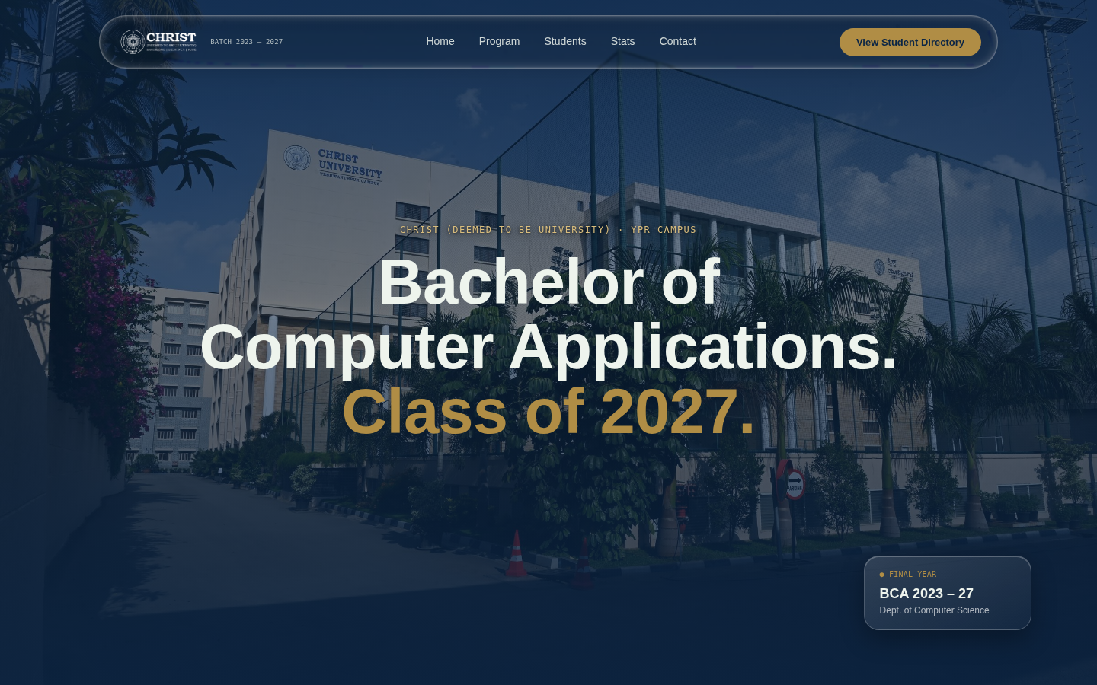
Figure 2. Landing page — programme, batch, and campus identification.
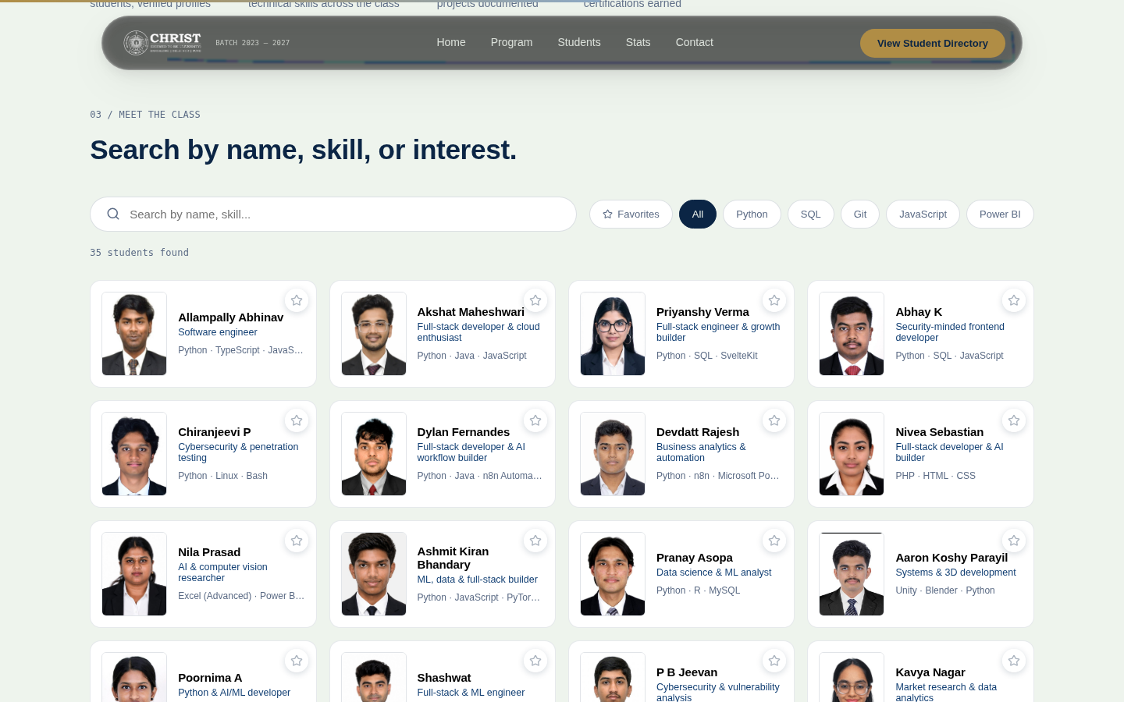
Figure 3. Student directory — all 35 profiles as cards, with search box and auto-generated skill-frequency filter pills (UC-1, UC-2).
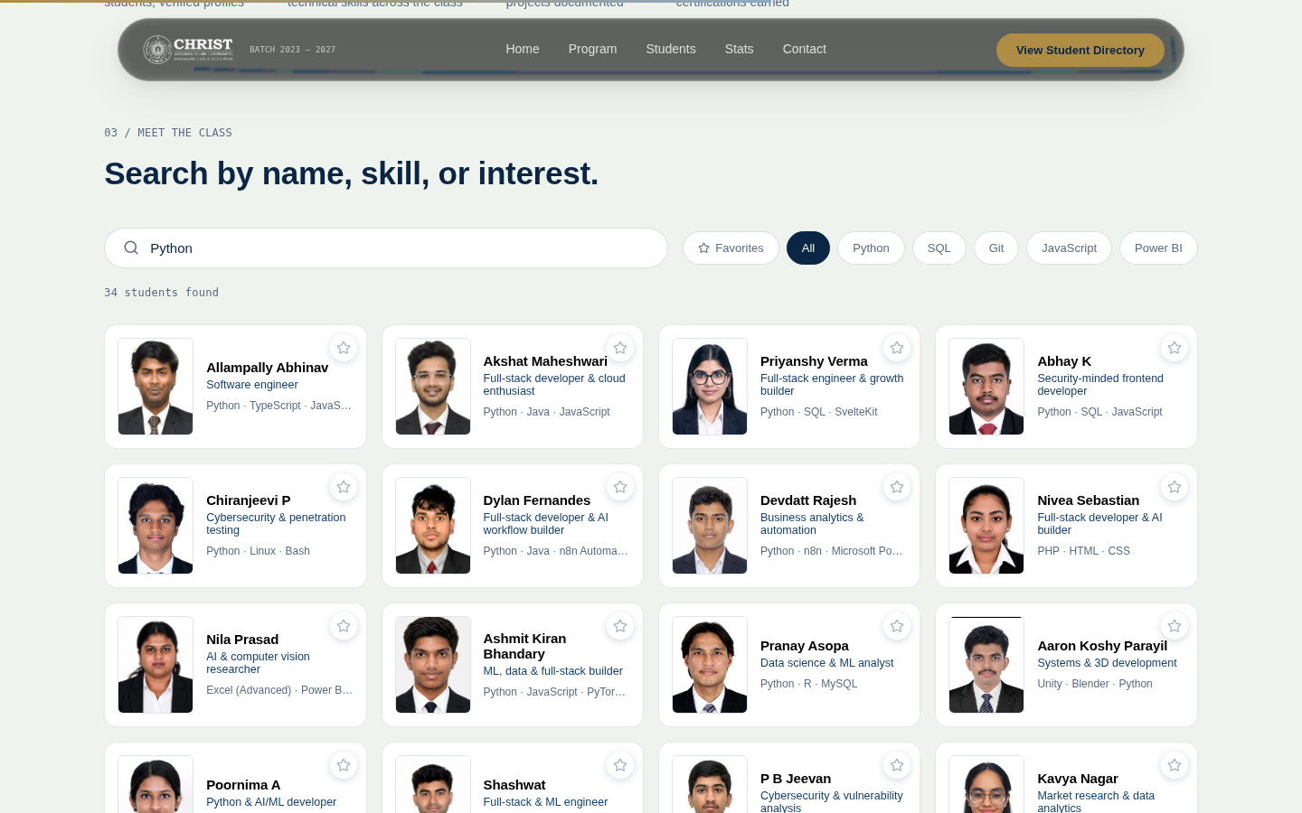
Figure 4. Live search narrowing the grid to students whose data includes "Python" (UC-2), demonstrating client-side filtering against the merged static + Firestore dataset.
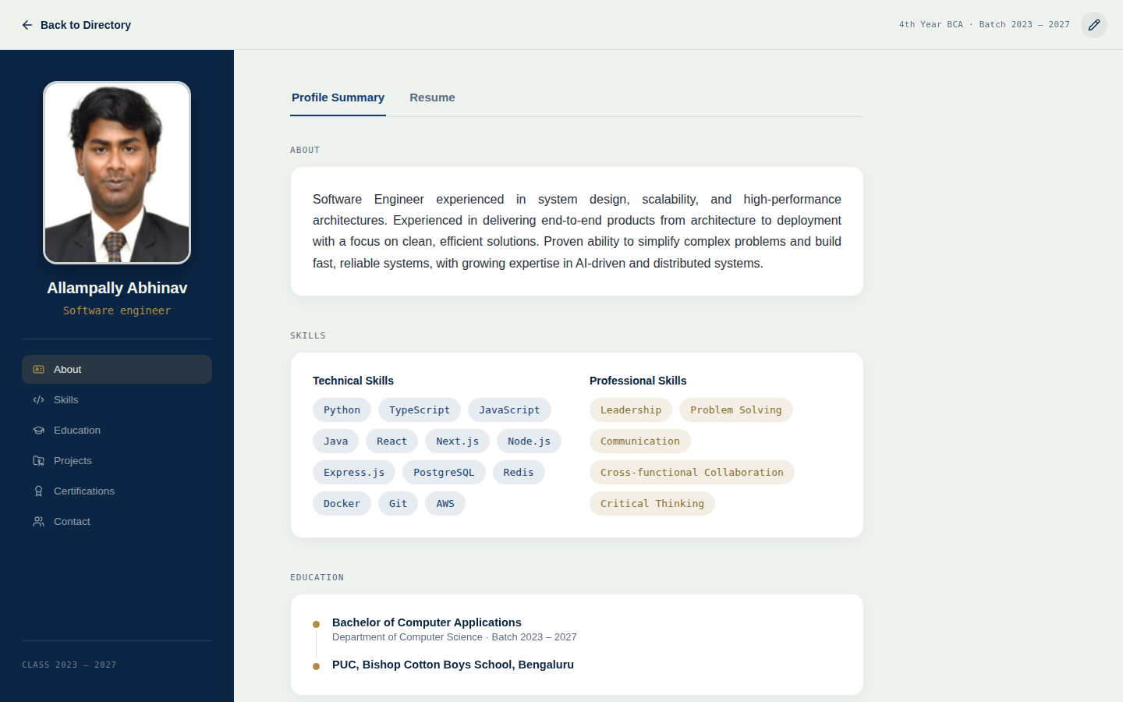
Figure 5. Full student profile page — photo, tagline, About section, and section navigation (UC-3).
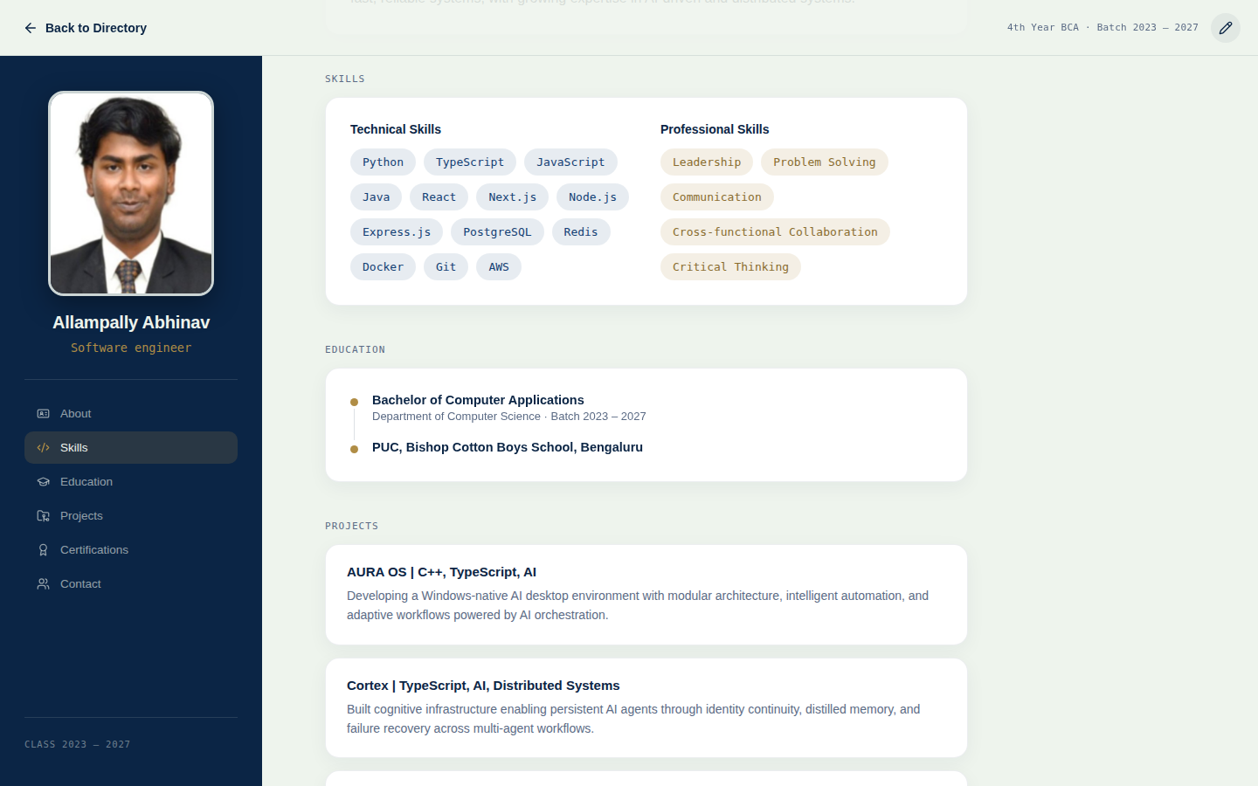
Figure 6. Skills and Education sections of a profile, showing the technical/professional skill split and the self-edit ("pencil") entry point in the header (UC-3, UC-7).

8.1 Summary of Outcomes
Metric | Result
Student profiles delivered | 35, each with up to 14 populated fields
Production build | Succeeds with Vite (2,288 modules transformed, ~2 s build time)
Database reads | Verified — full roster and live overrides load and render correctly
Database writes | Verified — setDoc with merge: true confirmed against studentEdits
Real-time sync | Verified — onSnapshot pushes updates to the UI without a page reload
Resume storage | Verified — static PDFs bundled at build time; self-upload path integrated with Cloudinary
Deployment | Live static build hosted on Vercel; alternate GitHub Actions → GitHub Pages workflow also configured

9. Conclusion and Future Scope
The project delivers a working, database-backed student directory that meets its stated objectives: all 35 members of the BCA 2023–2027 batch are searchable and browsable from a single site, each with a detailed, self-maintainable profile. The two-tier data design — a static baseline merged at render time with a small, live NoSQL overrides collection — keeps the database itself small and fast while still giving every student a real, immediate way to keep their own information current without developer involvement.
The clearest opportunity for future work is access control: the current write path is protected by a shared password and an email match performed in the browser, which is adequate for a low-stakes class directory but not a cryptographic guarantee. Replacing it with Firebase Authentication (e.g. email-link sign-in) and matching Firestore security rules to the signed-in user's verified email would let each student's write access be enforced by the database itself rather than by client-side convention. Additional natural extensions include an admin moderation view for edits, basic visit analytics, and migrating bundled media into Firebase Storage as the dataset grows beyond a single class.

